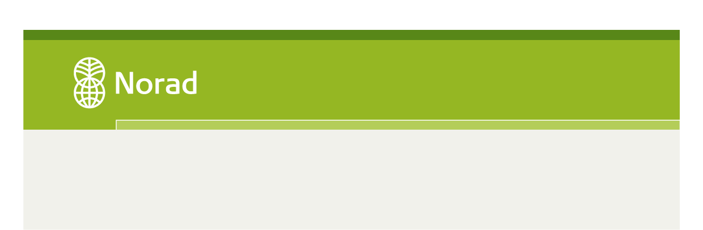
NORHED
Sub-programme: Education and Training
Application Form

Deadline for submission: 15.02.16, 15:00 CET (Central European Time)

Norad recommends all applicants to read the NORHED Guidelines carefully before filling out this application.
The application should be maximum 30 pages long (Calibri 11 points).
Projects recommended for funding may be requested to provide further documentation before final approval.

- Project information
Project title:
Country(ies) of implementation: |  | Implementation period:  Project financial year: |  |  | Amount applied for (in NOK):
Applying Higher Education Institutions (name of institutions):
Brief project description / Executive summary (200 words):

- Administration and partnership
2.1 Project partner information | Name of institution |  | Proposing unit at institution | Institutional contact person (name, position, and email) |  | Project coordinator  (name, position, and email)
Agreement partner institution
(only one)
LMIC Partner institution(s)
Norwegian partner institution(s)
2.2 About the partnership
Background and history of the partnership. Previous and ongoing cooperation projects:

Have the partners previously received grants from Norad or the Norwegian Ministry of Foreign Affairs, including Norwegian Embassies?
If yes, state the programme and project name, and give a brief summary of key results achieved to date:

Any other information and ongoing projects supported by other donors of relevance to the Project.

2.3 Description of the Agreement Partner :
- role in the project:
- institutional capacity and resources available/enabling environment:
- competence and qualifications in regards to the project’s thematic focus:
- experience from the geographical area concerned:
- any other relevant experience:

2.4 Description of the LMIC partner(s) :
- role in the project:
- institutional capacity and resources available/enabling environment:
- competence and qualifications in regards to the project’s thematic focus:
- experience from the geographical area concerned:
- any other relevant experience:
2.5 Description of the Norwegian partner(s):
- role in the project:
- institutional capacity and resources available/enabling environment:
- competence and qualifications in regards to the project’s thematic focus:
- experience from the geographical area concerned:
- any other relevant experience:
2.6 Assessment the institutional capacity to coordinate and implement the project, including assessment of financial management and anti-corruption strategies for the Project. Projects recommended for funding will be asked to provide documentation of the institutions’ anticorruption and procurement routines.

2.7 Gender Focal Point (must be a member of the project management):

- Description of the project
3.1 Brief description of the present situation at the institution(s) and country(ies) of implementation, and the need/justification for the project (baseline):

3.2 Description of the project and design (elaborate on the project’s proposal)

3.3 Assessment of how the project relates to national and partner institutions` strategic plans and priorities (in countries where capacity will be implemented):

- Results framework The results framework must adopt NORHED’s intended impact on society and relevant outcomes. The impact and outcome formulations are common for all NORHED projects as presented below (grey areas). The applicants are required to complete the results framework by clearly stating the major outputs to be delivered by the project, including indicators, baselines and targets (white areas). Indicators should be disaggregated by institution and by gender where relevant. Please make sure to include the 14 standard indicators, as presented in Standard indicators for the NORHED programme.
4.1. Intended impact on society: NORHED’s medium term impact: i) More and better qualified workforce, ii) increased knowledge, iii) evidence-based policy and decision-making and iv) enhanced gender equality
4.2. Intended outcomes:
Intended outcomes under NORHED are strong higher education institutions capable of:
a) Producing more and better research relevant to the identified areas/sub-programmes, and
b) Producing more and better qualified graduates, men and women, relevant to the identified areas/sub-programmes.
4.2.1. Outcome 1: More and better research | Indicator | Baseline value | Means of verification |  | Target final year
Output 1.1:
Output 1.2:
Output 1.3:
(continue below)
4.2.2. Outcome 2: More and better qualified graduates | Indicator | Baseline value | Means of verification |  | Target final year
Output 2.1:
Output 2.2:
Output 2.3:
(continue below)
4.3. Assumptions/risk factors
Please refer to numbered outcomes/outputs. Identify risk factors that might impede the implementation or have negative influence on the achievements of results, as well as possible negative effects of the intervention itself. Describe the likelihood of risk, the consequences, and the mitigation strategy planned for each described risk factor.
Assumption/Risk factors for Outcome 1: More and better research | Likelihood  (Likely/moderate/unlikely) | Consequence  (Severe/moderate/modest) |  | Mitigation strategy
Assumption/Risk factors for Outcome 2: More and better qualified graduates | Likelihood  (Likely/moderate/unlikely) | Consequence  ( Severe/moderate/modest) |  | Mitigation strategy
Assumption/Risk factors for outputs | Likelihood  (Likely/moderate/unlikely) | Consequence  ( Severe/moderate/modest) |  | Mitigation strategy
Output 1.1.

Output 1.2

5. Implementation plan
The implementation plan should provide an overview of the project activities.
Number | Activities:  The actions necessary to deliver the outputs described in 4.2. | Responsible partner | Planned start date | Planned end date

6. Assessment of sustainability and cross cutting issues.
6.1 Assessment of gender mainstreaming in relation to student and staff recruitment and as a dimension in the education and research programmes.

6.2 Assessment of Human Rights. Address issues related to human rights and inclusion
of marginalized groups relevant to the project.

6.3 Assessment of environmental and climate sustainability:

6.4 Assessment of sustainability beyond the project period:

7. Financial plan
7.3 Budget Summary (a detailed budget shall be submitted as an attachment)
The NORHED financial framework is structured into four main components listed below
Project categories | Agreement Partner | LMIC Partner(s) | Norwegian Partner(s) | Total project costs (NOK) | Percentage of total
I. Education (Bachelor & Master)
II. PhD and Research
III. Institutional Development
IV. Project Management
Sum
V. Admin. support
(max (7%)
TOTAL
7.1 Financial plan.
Provide a justification of the project’s financial plan and intended use of funds per component
- Education (Bachelor &Master level):

- PhD and Research:

- Institutional Development:

- Project Management:

  - Value for money/cost effectiveness (justification of the relevance and realism of the financial plan)

8. Date and confirmation

I am authorized to sign legally binding agreements on behalf of the applicant, and confirm that the information contained in this application is correct to the best of my knowledge.
I hereby commit to participate in NORHED evaluations irrespective of whether the application will receive funding or not.
Agreement Partner
Place and date | Name/Title  Sign:
Norwegian Partner
Place and date | Name/Title  Sign:
LMIC Partner(s)
Place and date | Name/Title

9. Attachments

The following attachments must be submitted together with the application. Incomplete applications will automatically be rejected.
- Application form
- Project Budget
- CVs
- Commitment letter

