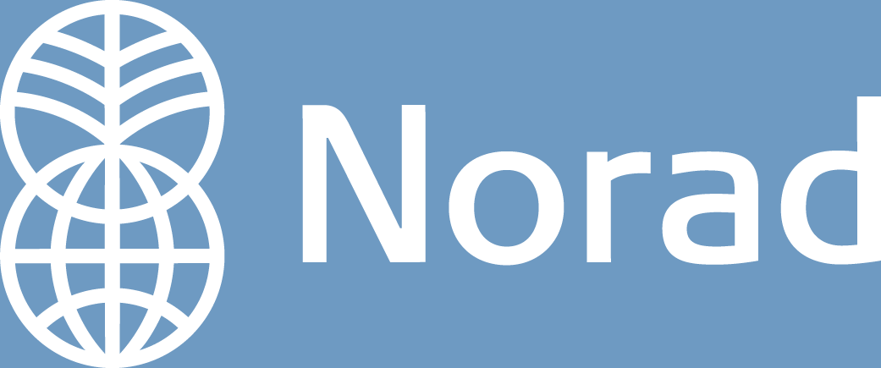

GUIDELINES

Support for Development of Clean Development Mechanism (CDM) Projects

1. Background

The Clean Development Mechanism (CDM) allows public or private entities to invest in greenhouse gas (GHG) mitigating project activities in developing countries and earn abatement credits, which can then be applied against their own GHG emissions or sold on the open market. The goals of CDM as defined in article 12 of the Kyoto Protocol are:

- to contribute to sustainable development in non-Annex I countries;
- to assist Annex I parties (countries with emission reduction target under the Kyoto Protocol) in complying with their emissions reduction commitments; and
- to contribute to the ultimate objective of UNFCCC (United Nations Framework Convention on Climate Change): the mitigation of climate change.

2. Support for development of CDM projects - Purpose

To contribute to the CDM goals the Norwegian Ministry of Foreign Affairs has through the Norwegian Agency for Development Cooperation (Norad) established a support mechanism to enable eligible entities (Project Developers) to prepare the necessary documentation for submission of CDM projects to the Designated National Authority (DNA) and the United Nations CDM Executive Board. Developing new CDM methodologies or adapting existing methodologies can also be supported.

A CDM project activity involves generally the following 5 stages: Stage 1: Project Idea; Stage 2: Project Design; Stage 3: Project Validation; Stage 4: Project Registration; and Stage 5: Credit Issuance and Delivery.

Norad may, in addition to the support described in this document, also support institutional cooperation and capacity building as part of the assistance to the CDM, including establishment of DNA. Such support will be based on an official request from the partner country.

Norad’s support for development of CDM projects does not cover activities linked to the purchase of Certified Emission Reductions (CERs).

The Norwegian Ministry of Finance, through Carbon Neutral Norway, is responsible for the purchase of CO₂ credits from CDM projects to meet Norway’s obligations under the Kyoto Protocol. More information can be found at: www.carbonneutralnorway.no.

3. Eligibility

Project Developers from Norway and Least Developed Countries (LDCs) may submit CDM project proposals under this Norad scheme.

A priority of the support mechanism is to promote projects and the transfer of environmental technology to the Least Developed Countries (LDCs), in particular to LDCs in Africa.

Eligible CDM projects shall lead to reductions of greenhouse gases (CO₂, CH₄, N₂O, HFC, PFC and/or SF6). Priority is given to:
- Renewable energy projects, such as: wind, solar, geothermal, (clean) biomass and hydro power.
- Energy efficiency improvement projects.
- Forestry projects (afforestation and reforestation) (as one of the land use, land use change and forestry (LULUCF) activities).
- Projects within other sectors can also be supported, e.g. transportation improvement projects, projects concerning recovery and utilisation of methane, for example from waste landfills or coal mines and projects concerning fossil fuel switching to less carbon-intensive sources.

Support can only be provided to CDM projects in non-Annex 1 countries where a DNA has been – or is in the process of being – established.

Additionality. It is required that CDM projects are additional, meaning that anthropogenic greenhouse gas emissions generated by the project are less than what would have occurred in the absence of the project activity. Also, each project should be able to argue that it would not have been implemented without the support of the CDM.

Sustainable Development. A CDM project must contribute to sustainable development in the host country. Since national policies on this issue may vary, the Project Developer is expected to contact the local DNA for adequate guidance. If the project has a negative impact on sustainable development, it would not qualify for CDM. In case, the sustainable development contribution is nil or neutral, the Project Developer might consider using part of the income from the credit sale to finance other activities that do contribute to sustainable development, such as activities improving the quality of life of the local community.

Support is not conditioned on the project entering into an agreement of sales of CERs to the Norwegian Ministry of Finance.

The support is contingent on the Project Developer not receiving similar support from other sources.

Support to eligible projects will be granted based on criteria defined above, including an assessment of the CDM potential of the project, an assessment of its technical and financial feasibility, as well as its potential for sustainable development. The Project Developer’s financial, technical and institutional/organizational capacity to realize the project and the Project Developer’s own risk taking as the owner, developer or investor in the project will be assessed. Norad support should be considered essential in order to ensure the realisation of the project.

4. Which costs will be covered?

Norad may provide partial funding, up to 50 %, of:

- costs related to producing a Project Design Document (PDD); and
- costs related to the development of new CDM methodologies or adapting existing methodologies. Higher support levels will be considered for the development of new CDM methodologies.

The eligible costs include project management, planning and preparation, field work, consultancy, etc.

Only costs incurred after the time of approval of Norad’s support are eligible. The costing of the project should comply with the principles of sound financial management, in particular value for money and cost-effectiveness.

Registration and application fees, as well as costs in connection with sales of CERs, are not covered. Investments in CDM projects or costs related to the implementation of CDM projects are not covered.

5. Terms of disbursement

Norad’s support is normally disbursed ex-post upon receipt of a report assessing the actual outputs vs. planned outputs, proof of development of the relevant documentation, use of funds, or as specified in the letter of approval.

6. How to apply

The application should be submitted to Norad. Norad will solicit input from relevant Embassies during the review of the application.

Annex I: How to apply

Applications should include the following elements:

Name and address of Applicant
Type of project | [Industry sector, type of GHG, type of technology]
Description of the Applicant | [Including the Applicant’s financial, organizational and technical ability to realize the project.  Provide information about previous contact with or support from Norad.]
Description of the Project | [Including:  - Background;  - Objectives;  - Brief description of technology to be used/transferred;  - CER potential and whether emission reductions are additional;  - Required investment  - Planned steps in the CDM process, including specification of the documentation that will be developed;  - Baseline and monitoring methodologies that will be used;  - Modalities and procedures for establishing a new CDM methodology, if relevant; and  - How the project will comply with other relevant requirements (specific DNA requirements).]
Time frame
Contribution to sustainable development | [The way the project will contribute to sustainable development, including local involvement, planned consultation and consideration of potential environmental impacts.]
Risks | [The application should consider risks threatening the implementation of the project, both internal and external. Such risks may be related to policy and framework conditions (including corruption), socio-cultural and gender conditions (including HIV/Aids), economy and finance, institutional and organizational challenges and/or environmental/technical/ technological conditions.]
Justification of support
Budget | [Specification of the costs to be covered]
Annexes | [Relevant documentation as available (PIN, Feasibility Study or other)]

Please submit your application to Norad: post-narut@norad.no

